## 6. Preliminary numerical simulations and computational model verification

This section is aimed at applying the computational modeling to simulate deformation and stress in two academic twin tunnels configurations. The numerical results provided in these illustrative applications may be viewed as preliminary verifications of the F.E formulation. The first application refers to unlined twin tunnels excavated in an elastic rock mass, whereas the second application addresses the situation of unlined twin tunnels excavated in an elastoplastic medium.

**6.1 Unlined twin tunnels in elastic medium**

## In the context of plane strain conditions, Guo et al. [6] addressed the configuration of deep twin tunnels excavated in a homogeneous elastic medium in which prevails a hydrostatic initial stress distribution. The authors formulated approximate analytical solutions for the stress distribution establishing far behind the face, which are induced in the rock mass by the excavation of two parallel circular tunnels. The model geometry of the twin circular tunnels as well as the loading associated with initial hydrostatic stress are displayed in Fig. 12.

Simulation of the problem has been addressed by means of the 3D finite element model and the numerical results obtained for the stress distribution far behind the faces of the twin tunnel shall be compared to the analytical stress solution derived by Guo et al**.** [6] in the framework of plane strain conditions. The simulations have been performed taking advantage of symmetry with respect to the midplane between twin tunnels and considering the following model data: tunnel radius 𝑅𝑡 = 4 m, rock Young modulus 𝐸 = 500 MPa and Poisson ratio 𝜈 = 0.23, isotropic initial stresses of 𝜎𝑣 = 𝜎ℎ = 2.2 MPa.

.

Figure 12: Geometry model and loading mode of the twin circular tunnels studied in Guo et al. [6].

Denoting by the displacement component following the -axis, Fig. 13 displays the convergence curves 𝑈𝐵 = −𝑢𝑦 (B)∕𝑅𝑡 that characterize the inward movement at the tunnel roof as a function of normalized longitudinal distance to the facing. Several values of normalized distances between the twin tunnels axes 𝑑1∕2𝑅𝑡 have been investigated, and the configuration of single tunnel may be viewed as the limiting case . It is recalled that in the latter configuration, the convergence far from the tunnel face that is obtained from an elastic analysis reads 𝑈 = 𝜎𝑣 (1+𝜈)∕𝐸. As expected, this figure indicates that the closer the longitudinal tunnels, the greater the convergence at the roof.

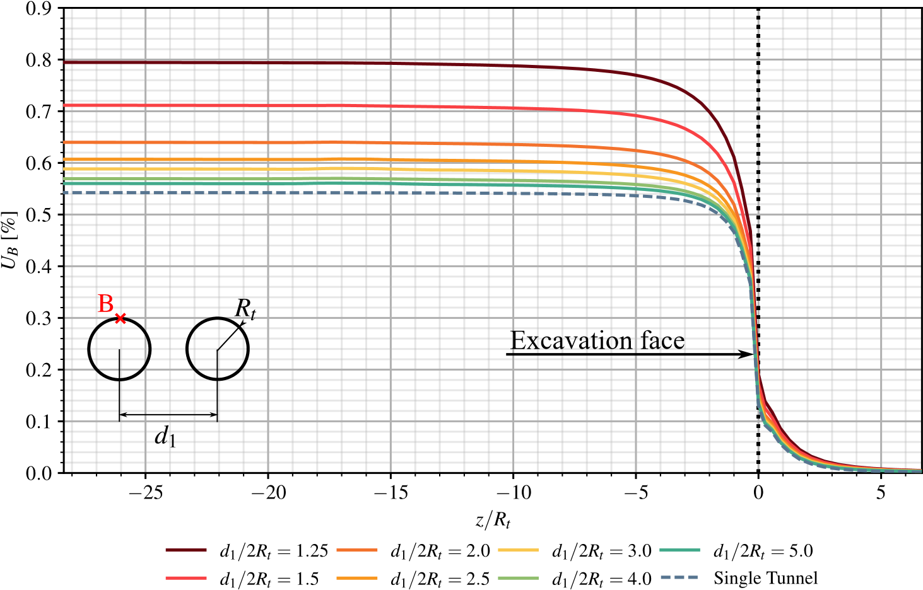

Figure 13: Convergence profiles at the tunnel roof B.

The tunnel deformation anisotropy induced by the twin tunnels proximity is illustrated in Fig. 14, which plots the ratio  between the vertical displacement at the roof B and the horizontal displacement at the side wall . The results refer to a tunnel section located far behind the facing at normalized distance 𝑧∕𝑅𝑡 = −25. They emphasize the significative tunnel ovalization induced by the proximity of twin tunnel as the distance  decreases.

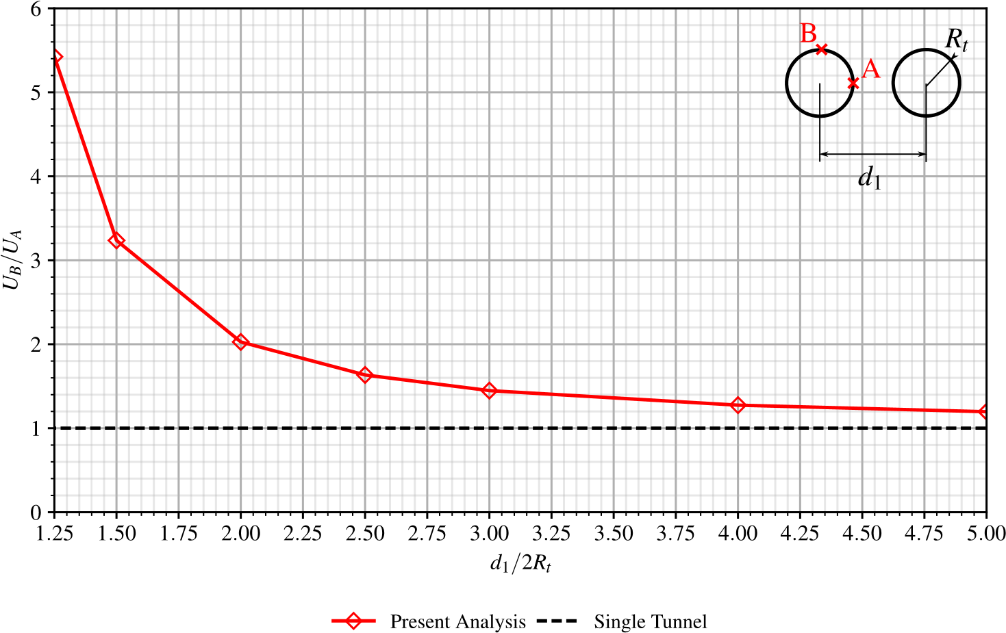Figure 14: Illustration of the tunnel wall deformation anisotropy induced by twin tunnels proximity.

The stress distribution prevailing far from the facing that were obtained from the 3D numerical simulations are compared in Fig. 15 to the stress solutions derived analytically and numerically in Guo et al. [6]. In this figure, the tangential stress concentration factor  computed at the sidewall  is plotted for several values of the normalized twin tunnels distance Finally, Fig. 16 displays the distribution of tangential stress 𝜎𝜃𝜃 around the tunnel boundary {r=Rt, 0 ≤ 𝜃 ≤ Pi} considering 𝑑1∕2𝑅𝑡 = 1.5. The predictions of stress component 𝜎𝜃𝜃 obtained from the 3D finite element. The results of the theoretical solution to a plate containing two circular holes of equal size presented in Ling et al. [37] are also reported in Fig. 15. It is observed that the results of the 3D finite element simulations correspond to a tunnel section located at normalized distance 𝑧∕𝑅𝑡 = −25 from the facing, which is considered sufficient for the plane strain conditions to establish. Interestingly, the tangential stress concentration obtained for a deep single tunnel under plane strain condition simply reads . Although the overall agreement observed between the different predictions, it appears from the comparison that the approximate analytical stress solution provided in [6] slightly overestimates the tangential stress computed at point A as the value of distance  increases.

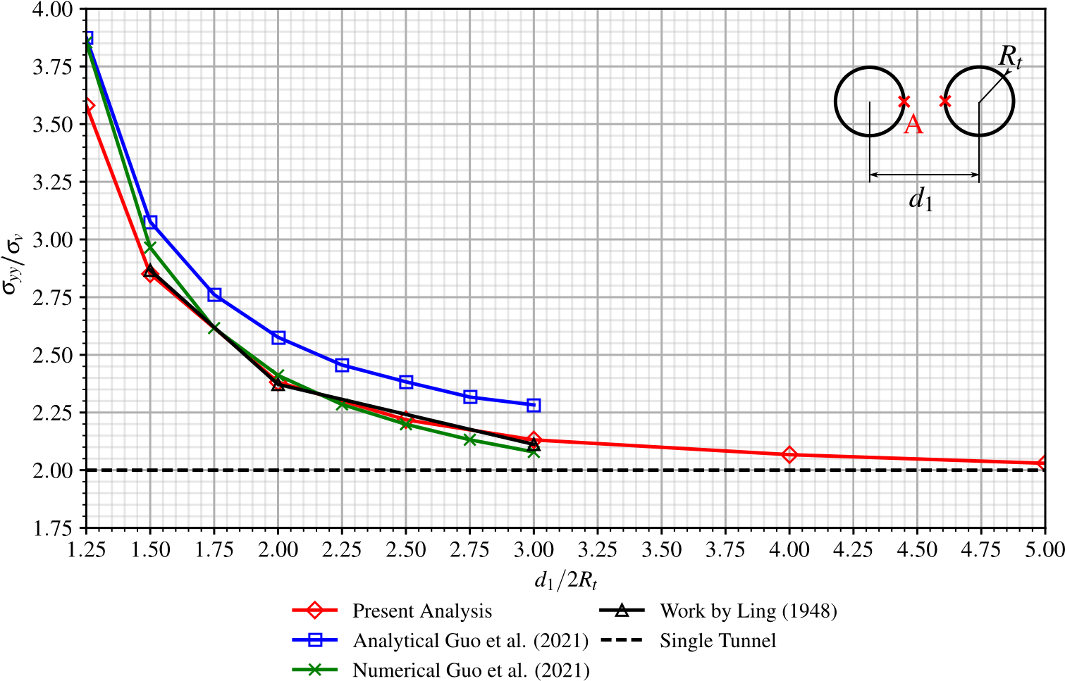

Figure 15: Tangential stress concentration factor at the side wall A versus twin tunnels distance .

Finally, Fig. 16 displays the distribution of tangential (orthoradial) stress 𝜎𝜃𝜃 around the tunnel boundary considering 𝑑1∕2𝑅𝑡 = 1.5. The predictions of stress component 𝜎𝜃𝜃 obtained from the 3D

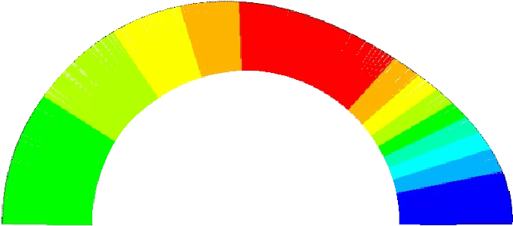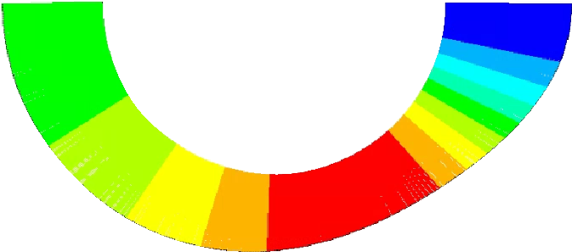

-3.80

Current

D model

3

solution

Analytical Solution

Guo, et al. (2021)

-6.30

-5.99

-5.69

-5.38

-5.07

-4.76

-4.45

-4.15

-3.84

-3.53

-5.00

-4.97

-4.13

-3.80

-3.74

-6.72

Figure 16: : Distribution of tangential stress 𝜎𝜃𝜃 around the tunnel wall prevailing far behind the facing ( twin tunnels distance 𝑑1∕2𝑅𝑡 = 1.5).

finite element simulations far behind the facing are shown together with the strain plane solutions derived analytically in [6], emphasizing the ability of the computational model to accurately capture the effect of tunnels proximity on stress distribution.

## Keeping in mind it addresses only an academic configuration, the results provided in this section may be viewed as a first preliminary verification of the accuracy of the computational model formulated for the mechanical interaction in deep twin tunnels.

## 7. References

1. Spyridis P, Bergmeister K. Analysis of lateral openings in tunnel linings. Tunnelling and Underground Space Technology 2015;50:376–395. doi:[https://doi.org/10.1016/j.tust.2015.08.005.](http://dx.doi.org/https://doi.org/10.1016/j.tust.2015.08.005)
2. Chen F, Lin Lb, Li D. Analytic solutions for twin tunneling at great depth considering liner installation and mutual interaction between

geomaterial and liners. Applied Mathematical Modelling 2019;73. doi:[https://doi.org/10.1016/j.apm.2019.04.026.](http://dx.doi.org/https://doi.org/10.1016/j.apm.2019.04.026)

1. Fortsakis P, Bekri E, Prountzopoulos G, Marinos P. Numerical analysis of twin tunnels interaction. In: Proc. 1st Eastern European Tunnelling Conference. Budapest, Hungary; 2012,.
2. Chortis F, Kavvadas M. Three-dimensional numerical analyses of perpendicular tunnel intersections. Geotechnical and Geological Engineering 2021;39:1771–1793.
3. Chortis F, Kavvadas M. Three-dimensional numerical investigation of the interaction between twin tunnels. Geotechnical and Geological Engineering 2021;39:5559–5585. doi:[https://doi.org/10.1007/s10706-021-01845-5.](http://dx.doi.org/https://doi.org/10.1007/s10706-021-01845-5)
4. Guo Z, Liu X, Zhu Z. An elastic solution for twin circular tunnels’ stress in hydrostatic stress field. Geotechnical and Geological Engineering 2021;39:1–11. doi:[https://doi.org/10.1007/s10706-021-01756-5.](http://dx.doi.org/https://doi.org/10.1007/s10706-021-01756-5)
5. Chortis F, Kavvadas M. 3D numerical investigation of the axial forces acting on tunnel junctions constructed in fractured/weathered to very blocky rockmass. In: Expanding Underground-Knowledge and Passion to Make a Positive Impact on the World. CRC Press; 2023, p. 1574–1582.
6. Chortis F, Kavvadas M. 3D numerical investigation of the bending moments acting on tunnel junctions constructed in fractured/weathered to very blocky rockmass. In: Expanding Underground-Knowledge and Passion to Make a Positive Impact on the World. CRC Press; 2023, p. 1583–1591.
7. Ma Y, Lu A, Zeng X, Cai H. Analytical solution for determining the plastic zones around twin circular tunnels excavated at great depth. International Journal of Rock Mechanics and Mining Sciences 2020;136:104475. doi:[https://doi.org/10.1016/j.ijrmms.2020.](http://dx.doi.org/https://doi.org/10.1016/j.ijrmms.2020.104475)

[104475](http://dx.doi.org/https://doi.org/10.1016/j.ijrmms.2020.104475).

1. Bažant ZP, Prasannan S. Solidification theory for concrete creep. I: Formulation. Journal of Engineering Mechanics 1989;115(8):1691–1703. doi:[https://doi.org/10.1061/(ASCE)0733-9399(1989)115:8(1691).](http://dx.doi.org/https://doi.org/10.1061/(ASCE)0733-9399(1989)115:8(1691))
2. Bažant ZP, Prasannan S. Solidification theory for concrete creep. II: Verification and application. Journal of Engineering Mechanics

1989;115(8):1704–1725. doi:[https://doi.org/10.1061/(ASCE)0733-9399(1989)115:8(1704).](http://dx.doi.org/https://doi.org/10.1061/(ASCE)0733-9399(1989)115:8(1704)) [12] ANSYS. ANSYS Programmer’s Reference, release 15.0. Canonsburg, Pennsylvania; 2013.

1. Nemat-Nasser S, Hori M. Micromechanics: overall properties of heterogeneous materials. North-Holland; 1993.
2. Deudé V, Dormieux L, Kondo D, Maghous S. Micromechanical approach to nonlinear poroelasticity: Application to cracked rocks. Journal

of Engineering Mechanics 2002;128(8):848–855. doi:[https://doi.org/10.1061/(ASCE)0733-9399(2002)128:8(848).](http://dx.doi.org/https://doi.org/10.1061/(ASCE)0733-9399(2002)128:8(848))

1. de Buhan P, Fréard J, Garnier D, Maghous S. Failure properties of fractured rock masses as anisotropic homogenized media. Journal of Engineering Mechanics 2002;128(8):869–875. doi:[https://doi.org/10.1061/(ASCE)0733-9399(2002)128:8(869).](http://dx.doi.org/https://doi.org/10.1061/(ASCE)0733-9399(2002)128:8(869))
2. Marmier R, Jeannin L, Barthélémy JF. Homogenized constitutive laws for rocks with elastoplastic fractures. International Journal for Numerical and Analytical Methods in Geomechanics 2007;31(10):1217–1237. doi:[https://doi.org/10.1002/nag.595.](http://dx.doi.org/https://doi.org/10.1002/nag.595)
3. Aguiar CB, Maghous S. A micromechanics-based approach to damage propagation criterion in viscoelastic fractured materials regarded as homogenized media. International Journal for Numerical and Analytical Methods in Geomechanics 2023;47(6):936–971. doi:[https:](http://dx.doi.org/https://doi.org/10.1002/nag.3500)

[//doi.org/10.1002/nag.3500.](http://dx.doi.org/https://doi.org/10.1002/nag.3500)

1. Rousset G. Comportement mecanique des argiles profondes: Application au stockage de déchets radioactifts. Ph.D. Thesis (in french); Ecole Nationale des Ponts et Chaussées; Paris, France; 1988. URL: [https://theses.hal.science/tel-00529719/.](https://theses.hal.science/tel-00529719/)
2. Nguyen Minh D, Rousset G. Influence of instantaneous failure on time dependent behavior of underground galleries. In: The 28th U.S. Symposium on Rock Mechanics (USRMS). Tucson, Arizona; 1987, p. ARMA–87–0663. URL: [https://onepetro.org/ARMAUSRMS/ proceedings-abstract/ARMA87/All-ARMA87/129838.](https://onepetro.org/ARMAUSRMS/proceedings-abstract/ARMA87/All-ARMA87/129838)
3. Giraud A, Rousset G. Time-dependent behaviour of deep clays. Engineering Geology 1996;41(1):181–195. doi:[https://doi.org/10.](http://dx.doi.org/https://doi.org/10.1016/0013-7952(95)00000-3)

[1016/0013-7952(95)00000-3.](http://dx.doi.org/https://doi.org/10.1016/0013-7952(95)00000-3)

1. Bernaud D, Rousset G. L’essai de soutènement à convergence controlée. In: Proc. of International Symposium, Geotechnical Engineering of Hard Soils-Soft Rocks. Athens; 1993, p. 1381–1391.
2. Piepi GT. Comportement viscoplastique avec rupture des argiles raides. applications aux ouvrages souterrains. Ph.D. Thesis (in french); Ecole Nationale des Ponts et Chaussées; Paris, France; 1995. URL: [https://pastel.hal.science/tel-00523616/document.](https://pastel.hal.science/tel-00523616/document)
3. Quevedo FPM. Análise computacional das deformações em túneis profundos considerando o acoplamento plasticidade-viscoplasticidade. Ph.D. Thesis (in portuguese); Federal University of Rio Grande do Sul; Porto Alegre, Brazil; 2021. URL: [https://lume.ufrgs.br/ handle/10183/239617.](https://lume.ufrgs.br/handle/10183/239617)
4. Quevedo FPM, Bernaud D, Maghous S. Numerical integration scheme for coupled elastoplastic–viscoplastic constitutive law for tunnels. International Journal of Geomechanics 2022;22(10). doi:[https://doi.org/10.1061/(ASCE)GM.1943-5622.0002512.](http://dx.doi.org/https://doi.org/10.1061/(ASCE)GM.1943-5622.0002512)
5. Bernaud D. Tunnels profonds dans les milieux viscoplastiques: approches expérimentale et numérique. Ph.D. Thesis (in french); Ecole Nationale des Ponts et Chaussées; Paris, France; 1991. URL: [https://theses.hal.science/tel-00529719/.](https://theses.hal.science/tel-00529719/)
6. Perzyna P. Fundamental problems in viscoplasticity. In: Advances in applied mechanics; vol. 9. Elsevier; 1966, p. 243–377.
7. CEB-FIP . CEB-FIP model code 1990: Design code. Comité Euro International du Béton and Fédération Internationale de la Précontrainte (CEB-FIP); 1993.
8. Quevedo FPM, Schmitz RJ, Morsch IB, A. CF, Bernaud D. Customization of a software of finite elements to analysis of concrete structures: long-term effects. IBRACON Structures and Materials Journal 2018;11(4):696–718. doi:[https://doi.org/10.1590/](http://dx.doi.org/https://doi.org/10.1590/S1983-41952018000400005)

[S1983-41952018000400005.](http://dx.doi.org/https://doi.org/10.1590/S1983-41952018000400005)

1. Quevedo FPM, Bernaud D, Campos Filho A. Numerical analysis of deep tunnels in viscoplastic rock mass considering the creep and shrinkage of the concrete lining. International Journal of Geomechanics 2022;22(4). doi:[https://doi.org/10.1061/(ASCE)GM.1943-5622.](http://dx.doi.org/https://doi.org/10.1061/(ASCE)GM.1943-5622.0002282)

[0002282](http://dx.doi.org/https://doi.org/10.1061/(ASCE)GM.1943-5622.0002282).

1. Quevedo FPM. Comportamento a longo prazo de túneis profundos revestidos com concreto: modelo em elementos finitos. Master Thesis (in portuguese); Federal University of Rio Grande do Sul; Porto Alegre, Brazil; 2017. URL: [https://lume.ufrgs.br/handle/10183/](https://lume.ufrgs.br/handle/10183/163886)

[163886](https://lume.ufrgs.br/handle/10183/163886).

1. Bernaud D, Debuhan P, Maghous S. Numerical-simulation of the convergence of a bolt-supported tunnel through a homogenization method. International Journal for Numerical and Analytical Methods in Geomechanics 1995;19(4):267–288. doi:[https://doi.org/10.1002/nag.](http://dx.doi.org/https://doi.org/10.1002/nag.1610190404)

[1610190404](http://dx.doi.org/https://doi.org/10.1002/nag.1610190404).

1. Bernaud D, Maghous S, Debuhan P, Couto E. A numerical approach for design of bolt-supported tunnels regarded as homogenized structures. Tunneling and underground space technology 2009;24(5):533–546. doi:[https://doi.org/10.1016/j.tust.2009.02.002.](http://dx.doi.org/https://doi.org/10.1016/j.tust.2009.02.002)
2. Maghous S, Bernaud D, Couto E. Three-dimensional numerical simulation of rock deformation in bolt-supported tunnels: A homogenization

approach. Tunneling and Underground Space Technology 2012;31:267–288. doi:[https://doi.org/10.1016/j.tust.2012.04.008.](http://dx.doi.org/https://doi.org/10.1016/j.tust.2012.04.008)

1. Zienkiewicz O, Cormeau I. Visco-plasticity—plasticity and creep in elastic solids—a unified numerical solution approach. International Journal for Numerical Methods in Engineering 1974;8(4):821–845. doi:[https://doi.org/10.1002/nme.v8:4.](http://dx.doi.org/https://doi.org/10.1002/nme.v8:4) [35] Simo JC, Hughes TJR. Computational Inelasticity. Springer-Verlag; 1998.
2. Corbetta F. Nouvelles méthodes d’étude des tunnels profonds: calculs analytiques et numériques. Ph.D. Thesis (in french); Ecole Nationale des Ponts et Chaussées; Paris, France; 1990. URL: [https://theses.fr/1990ENMP0227.](https://theses.fr/1990ENMP0227)
3. Ling C. On the stresses in a plate containing two circular holes. Journal of Applied Physics 1948;19(1):77–82. doi:[https://doi.org/10.](http://dx.doi.org/https://doi.org/10.1063/1.1697875)

[1063/1.1697875.](http://dx.doi.org/https://doi.org/10.1063/1.1697875)